# LAPORAN AKHIR PRAKTIKUM DASAR-DASAR PEMROGRAMAN



Oleh:

MUHAMMAD RIDHO N/124240137

**PROGRAM STUDI SISTEM INFORMASI**

**JURUSAN INFORMATIKA**

**FAKULTAS TEKNIK INDUSTRI**

**UNIVERITAS PEMBANGUNAN NASIONAL “VETERAN” YOGYAKARTA**

**2024**

# HALAMAN PENGESAHAN

**LAPORAN AKHIR**

Disusun oleh:

MUHAMMAD RIDHO N 124240137

Telah Diperiksa dan Disetujui oleh Asisten Praktikum Dasar-Dasar Pemrograman

Pada Tanggal: 18,NOVEMBER 2024

|  |  |
| --- | --- |
| **Menyetujui,**  **Asisten Praktikum**  **Siti Fatimahtul Ughro**  **12422067** | **Asisten Praktikum**  **Laras Ayodya Sari**  **123220081** |

# KATA PENGANTAR

Puji syukur kami panjatkan kepada Tuhan Yang Maha Esa yang senantiasa mencurahkan rahmat dan hidayah-Nya sehingga kami dapat menyelesaikan praktikum Dasar-Dasar Pemrograman serta laporan akhir praktikum Dasar-Dasar Pemrograman. Adapun laporan ini berisi tentang kumpulan tugas dan evaluasi dari hasil pembelajaran selama praktikum berlangsung.

Tidak lupa ucapan terima kasih kepada asisten dosen yang selalu membimbing dan mengajari kami dalam melaksanakan praktikum dan dalam menyusun laporan ini. Laporan ini masih sangat jauh dari kesempurnaan, oleh karena itu kritik serta saran yang membangun kami harapkan untuk menyempurnakan laporan akhir ini.

Atas perhatian dari semua pihak yang membantu penulisan ini, kami ucapkan terima kasih. Semoga laporan ini dapat dipergunakan seperlunya.

Yogyakarta, (14,november 2024)

Penyusun

DAFTAR ISI

LAPORAN AKHIR PRAKTIKUM DASAR-DASAR PEMROGRAMAN i

HALAMAN PENGESAHAN ii

KATA PENGANTAR iii

TUGAS 1 INPUT 1

2.1 Source Code Program 1

2.2 Catatan Revisi 2

2.3 Revisi Program 2

2.4 Screenshot Program 2

TUGAS 2 OUTPUT 3

2.1 Source Code Program 3

2.2 Catatan Revisi 4

int main tidak boleh ada dua ya, tolong dipisah saja atau salah satu int mainnya dihapus. 4

2.3 Revisi Program 4

2.3 Screenshot Program 6

TUGAS 3 7

3.1 Source code program 7

3.2 CATATN REVISI 9

3.3 REVISI SOURCE CODE 9

3.4 Screenshot program 14

TUGAS 4 15

4.1 Source code program 15

4.2 CATATAN REVISI 18

4.3 SOURCE CODE REVISI 18

4.4 Screenshot program 19

TUGAS 1  
INPUT

Pada tugas pertama disini akan membuat sebuah program input yaang akan menghasilkan sebuah data pribadi.

## Source Code Program

|  |
| --- |
| 1. #include <iostream> 2. #include <string> 3. using namespace std; 4. int main() { 5. string nama; 6. string nim; 7. char jenisKelamin; 8. string alamat; 9. string agama; 10. string email; 11. string no, HP; 12. //memasukan data diri 13. cout << "Welcome kawan tolong isi data diri" << endl; 14. cout << "Masukkan nama kamu:";getline(cin, nama); 15. cout << "Masukkan nim kamu:";cin >> nim; 16. cout << "Masukkan jenis kelamin kamu (L=Laki-laki/P=Perempuan):";cin >> jenisKelamin; 17. cin.ignore(); 18. cout << "Masukkan alamat domisili kamu saat ini:";getline(cin, alamat); 19. cout << "Masukkan agama kamu: ";getline(cin, agama); 20. cout << "Masukkan email kamu:";cin >> email; 21. cout << "Masukkan no hp kamu'aktif':";cin >> no ; 22. //hasil data driri 23. cout << "\n--- data diri kamu! ---" << endl; 24. cout << "Nama : " << nama << endl; 25. cout << "nim : " << nim << endl; 26. cout << "Jenis Kelamin : " << (jenisKelamin == 'L' ? "Laki-laki" : "Perempuan") << endl; 27. cout << "Alamat : " << alamat << endl; 28. cout << "Agama : " << agama << endl; 29. cout << "email : " << email << endl; 30. cout << "no hp : " << no << endl; 31. return 0; 32. } |

## 

## Catatan Revisi

Tidak ada revisi

## Revisi Program

|  |
| --- |
| - |

## 

## Screenshot Program

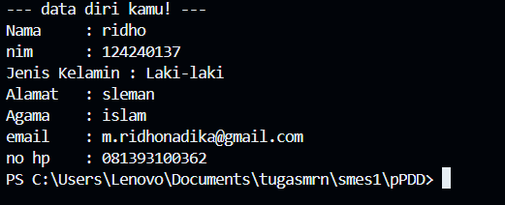1.3.1 masukan data diri

1.3.2 hasil

# TUGAS 2 OUTPUT

Tugas 2 *OUTPUT* adalah membuat suatu program yang bisa mengeluarkan suatu yang sudah dimasukan melalui INTUP.

## Source Code Program

|  |
| --- |
| #include <iostream>  #include <iomanip>  using namespace std;  int main() {  string nama, nim, plug;  cout << "Masukkan : " << endl;  cout << "Nama : ";  getline(cin, nama);  cout << "NIM : ";  cin >> nim;  cout << "Plug : ";  cin >> plug;  cout << "\nInilah data diri kamu: " << endl;  cout << "Nama : " << nama << endl;  cout << "NIM : " << nim << endl;  cout << "Plug : " << plug << endl;    cout << "\nDalam bentuk tabel : " << endl;  cout << "===================================================================================================" << endl;  cout << setw(12) << "NIM" << " | "  << setw(12) << "Nama" << " | "  << setw(12) << "Plug" << " |" << endl;  cout << "===================================================================================================" << endl;  cout << setw(12) << nim << " | "  << setw(12) << nama << " | "  << setw(12) << plug << " | " << endl;  cout << "---------------------------------------------------------------------------------------------------" << endl;  return 0;  }  #include <iostream>  #include <math.h>  using namespace std;  int main() {  double c, fahrenheit, kelvin, reaumur;  cout << "Masukkan suhu dalam Celcius: ";  cin >> c;  fahrenheit = (9.0 / 5.0) * c + 32;  kelvin = 273 + c;  reaumur = (4.0 / 5.0) * c;  cout << "\nHasil konversi suhu:" << endl;  cout << "Fahrenheit : " << fahrenheit << " ^F" << endl;  cout << "Kelvin : " << kelvin << " ^K" << endl;  cout << "Reaumur : " << reaumur << " ^R" << endl;  return 0;  } |

## 

## Catatan Revisi

## int main tidak boleh ada dua ya, tolong dipisah saja atau salah satu int mainnya dihapus.

## Revisi Program

|  |
| --- |
| * #include <iostream> * #include <iomanip> * using namespace std; * int main() { * string nama, nim, kelas; * cout << "Masukkan :\n"; * cout << "Nama : "; getline(cin, nama); * cout << "NIM : "; getline(cin, nim); * cout << "kelas : "; getline(cin, kelas); * cout << "\nInilah data Anda :\n"; * cout << "Nama : " << nama << endl; * cout << "NIM : " << nim << endl; * cout << "Plug : " << kelas << endl; * cout << "\nDalam bentuk tabel :\n"; * cout << "=========================================\n"; * cout << "NIM | Nama | kelas \n"; * cout << "=========================================\n"; * cout << setw(12) << left << nim << " | " * << setw(14) << left << nama << " | " * << setw(7) << left << kelas << endl; * cout << "-----------------------------------------\n"; * //menghitung suhu * float celsius, fahrenheit, kelvin, reamur; * cout << "\nMasukkan suhu dalam Celsius: "; * cin >> celsius; * fahrenheit = (9.0 / 5 * celsius) + 32; * kelvin = 273 + celsius; * reamur = (4.0 / 5 * celsius); * cout << "\nHasil konversi:\n"; * cout << "Fahrenheit : " << fahrenheit << endl; * cout << "Kelvin : " << kelvin << endl; * cout << "Reamur : " << reamur << endl; * return 0; * } |

## Screenshot Program

*Gambar 2.3.1 hasil output*

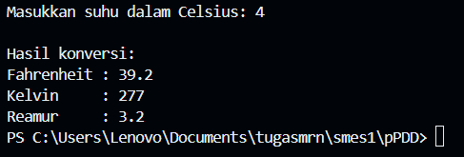

*Gambar 2.3.2 menghitung suhu*

# TUGAS 3

LATIHAN KUIS

Dalam tugas 4 ini membuat sebuah program kasir yang dapat digunakan setelah melewati sistem login dan ditambah dengan menggunakan looping untuk menjalankannya.

## Source code program

|  |
| --- |
| * #include <iostream> * using namespace std; * int main(){ * int harga, jml_barang, total, pilihan; * string item; * cout<<"====================================="<<endl; * cout<<" program kasir"<<endl; * cout<<"====================================="<<endl; * cout<<"barang tersidia : "<<endl; * cout<<"001. Paracetamol 500mg \t: Rp 50,000"<<endl; * cout<<"002. Amoxillin \t: Rp 16,000"<<endl; * cout<<"003. Combantrin \t: Rp 25,000"<<endl; * cout<<"004. Tolak angin / box \t: Rp 33,000"<<endl; * cout<<"005. Mixagrip \t: 3,000"<<endl; * cout<<"====================================="<<endl; * cout<<"006. Selesai"<<endl; * do{ * cout<<"Isikan kode : "; * cin>>pilihan; * switch (pilihan){ * case 1 : * item = "Paracetamol 500mg"; * harga = 50000; * cout<<"jml_item :"; * cin>>jml_barang; * total += harga * jml_barang; * cout<<jml_barang<<" "<<item; * cout<<" = Rp. "<<harga*jml_barang<<endl; * break; * case 2 : * item = "Amoxillin"; * harga = 16000; * cout<<"jml_item :"; * cin>>jml_barang; * total += harga * jml_barang; * cout<<jml_barang<<" "<<item; * cout<<" = Rp. "<<harga*jml_barang<<endl; * break; * case 3 : * item = "Combantrin"; * harga = 25000; * cout<<"jml_item :"; * cin>>jml_barang; * total += harga * jml_barang; * cout<<jml_barang<<" "<<item; * cout<<" = Rp. "<<harga*jml_barang<<endl; * break; * case 4 : * item = "Tolak angin / box"; * harga = 33000; * cout<<"jml_item :"; * cin>>jml_barang; * total += harga * jml_barang; * cout<<jml_barang<<" "<<item; * cout<<" = Rp. "<<harga*jml_barang<<endl; * break; * case 5 : * item = "Mixagrip"; * harga = 3000; * cout<<"jml_item :"; * cin>>jml_barang; * total += harga * jml_barang; * cout<<jml_barang<<" "<<item; * cout<<" = Rp. "<<harga*jml_barang<<endl; * break; * case 6 : * cout<<"Total belanja : Rp. "<<total<<endl; * pilihan = 6; * break; * default : * cout<<"pilihan salah"<<endl;; * break; * } * }while(pilihan != 6); * cout<<"Terimakasih"<<endl; * return 0; * } |

## CATATN REVISI

 diperbaiki dan ditambahkan fiturnya ya. buat loginnya, dan fitur diskonnya. itu dia masih jadi infinite looping.

## REVISI SOURCE CODE

|  |
| --- |
| * #include <iostream> * #include <string> * #include <math.h> * using namespace std; * int harga, password, jml_barang, tgl, diskon, total, diskon1, diskondb, pilihan, bayar, kembalian; * string item, username, pembeli, member, ya; * int main(){ * cout<<"<======================================="<<endl; * cout<<"< >"<<endl; * cout<<"< APOTIK >"<<endl; * cout<<"< >"<<endl; * cout<<"<======================================="<<endl; * cout<<"masukan password :"; cin>>password; * cout<<"masukan username :"; cin>>username; * if (password == 124240137 && username == "mrnyk" ) * { * cout<<"<======================================>\n"; * cout<<"< >\n"; * cout<<"< WELCOME >\n"; * cout<<"< >\n"; * cout<<"<======================================>\n"; * cout<<"barang tersidia : "<<endl; * cout<<"001. Paracetamol 500mg \t: Rp 50,000"<<endl; * cout<<"002. Amoxillin \t: Rp 16,000"<<endl; * cout<<"003. Combantrin \t: Rp 25,000"<<endl; * cout<<"004. Tolak angin / box \t: Rp 33,000"<<endl; * cout<<"005. Mixagrip \t: 3,000"<<endl; * cout<<"006. selesai \t"<<endl; * }else{ * cout<<"<======================================>\n"; * cout<<"< >\n"; * cout<<"< KESALAHAN SISTEM >\n"; * cout<<"< >\n"; * cout<<"<======================================>\n"; * return 0; * } * do{ * cout<<"Isikan kode : "; * cin>>pilihan; * switch (pilihan){ * case 1 : * item = "Paracetamol 500mg"; * harga = 50000; * cout<<"jml_item :"; * cin>>jml_barang; * total += harga * jml_barang; * cout<<jml_barang<<" "<<item; * cout<<" = Rp. "<<harga*jml_barang<<endl; * break; * case 2 : * item = "Amoxillin"; * harga = 16000; * cout<<"jml_item :"; * cin>>jml_barang; * total += harga * jml_barang; * cout<<jml_barang<<" "<<item; * cout<<" = Rp. "<<harga*jml_barang<<endl; * break; * case 3 : * item = "Combantrin"; * harga = 25000; * cout<<"jml_item :"; * cin>>jml_barang; * total += harga * jml_barang; * cout<<jml_barang<<" "<<item; * cout<<" = Rp. "<<harga*jml_barang<<endl; * break; * case 4 : * item = "Tolak angin / box"; * harga = 33000; * cout<<"jml_item :"; * cin>>jml_barang; * total += harga * jml_barang; * cout<<jml_barang<<" "<<item; * cout<<" = Rp. "<<harga*jml_barang<<endl; * break; * case 5 : * item = "Mixagrip"; * harga = 3000; * cout<<"jml_item :"; * cin>>jml_barang; * total += harga * jml_barang; * cout<<jml_barang<<" "<<item; * cout<<" = Rp. "<<harga*jml_barang<<endl; * break; * case 6 :if (total > 200000) * { * cout<<"apakah member ? ";cin>>member; * if ( member == ya ) * { * diskon = total * 0.15; * diskon1 = total - diskon; * cout<<"TOTAL BELANJA : "<<diskon1<<endl; * cout<<"PEMBAYARAN : ";cin>>bayar; * kembalian = bayar - diskon1; * cout<<"kembalian : "<<kembalian<<endl; * }else{ * diskon = total * 0.05; * diskondb = total - diskon; * cout<<"TOTAL BELANJA : "<<diskondb<<endl; * cout<<"pembayaran : ";cin>>bayar; * kembalian = bayar - diskondb; * cout<<"kembalian : "<<kembalian<<endl; * } * }else * { * cout<<"TOTAL BELAJAN : "<<total<<endl; * cout<<"PEMBAYARAN : ";cin>>bayar; * kembalian = bayar - total; * cout<<"KEMBALIAN : "<<kembalian<<endl; * } * pilihan = 6; * break; * default : * cout<<"pilihan salah"<<endl; * break; * } * }while(pilihan != 6); * cout<<"Terimakasih"<<endl; * return 0; * } |
|  |

## Screenshot program

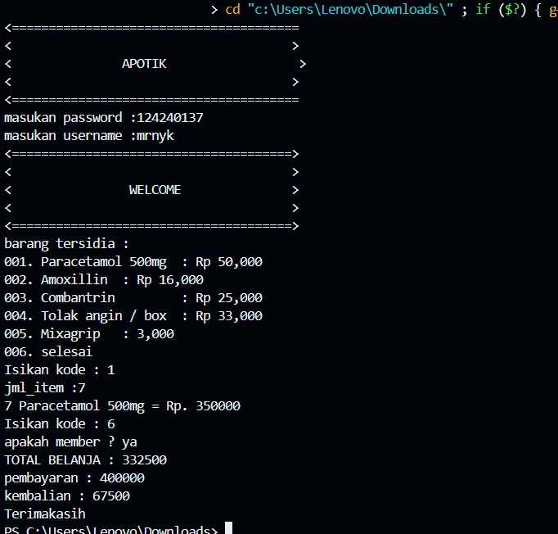

3.4.1 hasil looping

# TUGAS 4

PROGRAM KASIR

Pada tugas disini membuat sebuah program kasir dengan looping yang pada saat jumlah belanjaan lebih dari 100.000 ridbu maka akan mendapatkan diskon sebessar 5%

## Source code program

|  |
| --- |
| * #include <iostream> * #include <string> * using namespace std; * string nama, produk, username, buah; * int kode, harga, ttlharga, password, barang, jumlah, diskon, total, bayar, total1, total2, totalb; * int main(){ * cout<<"<======================================="<<endl; * cout<<"< >"<<endl; * cout<<"< RSHOP >"<<endl; * cout<<"< >"<<endl; * cout<<"<======================================="<<endl; * cout<<"masukan password :"; cin>>password; * cout<<"masukan username :"; cin>>username; * if (password == 124240137 && username == "mrn" ) * { * cout<<"<======================================>\n"; * cout<<"< >\n"; * cout<<"< WELCOME >\n"; * cout<<"< >\n"; * cout<<"<======================================>\n"; * cout<< "kode | produk | harga\n"; * cout<< "001b | jeruk | 15000\n"; * cout<< "002b | angur | 18000\n"; * cout<< "003b | melon | 14000\n"; * cout<< "004b | mangga | 16000\n"; * cout<< "005b | pepaya | 14500\n"; * }else{ * cout<<"<======================================>\n"; * cout<<"< >\n"; * cout<<"< KESALAHAN SISTEM >\n"; * cout<<"< >\n"; * cout<<"<======================================>\n"; * return 0; * } * do{ * cout<<"Isikan kode :"; * cin>>harga; * switch (harga){ * case 1 : * buah = "jeruk"; * harga = 15000; * cout<<"jml_item :"; * cin>>barang; * total += harga * barang; * total1 += harga * barang; * cout<<barang<<" "<<buah; * cout<<" = Rp. "<<harga*barang<<endl; * break; * case 2 : * buah = "anggur"; * harga = 18000; * cout<<"banyak buah :"; * cin>>barang; * total += harga * barang; * total1 += harga * barang; * cout<<barang<<" "<<buah; * cout<<" = Rp. "<<harga*barang<<endl; * break; * case 3 : * buah = "melon"; * harga = 14000; * cout<<"banyak buah :"; * cin>>barang; * total += harga * barang; * total1 += harga * barang; * cout<<barang<<" "<<buah; * cout<<" = Rp. "<<harga*barang<<endl; * break; * case 4 : * buah = "mangga"; * harga = 16000; * cout<<"banyak buah :"; * cin>>barang; * total += harga * barang; * total1 += harga * barang; * cout<<barang<<" "<<buah; * cout<<" = Rp. "<<harga*barang<<endl; * break; * case 5 : * buah = "pepaya"; * harga = 14500; * cout<<"banyak buah :"; * cin>>barang; * total += harga * barang; * total1 += harga * barang; * cout<<barang<<" "<<buah; * cout<<" = Rp. "<<harga*barang<<endl; * break; * case 6 : if (total > 100000){ * diskon = total * 0.05; * total2 = total1 - diskon; * cout<<"yang perlu dibayar : Rp. "<<total2<<"\ndibayar :";cin>>bayar; * cout<<"KEMBALIAN : Rp."<<bayar - total2; * }else{ * cout<<"yang perlu dibayar : Rp. "<<total <<"\ndibayar :";cin>>bayar; * cout<<"KEMBALIAN : Rp."<<bayar - total1; * harga = 6;} * break; * default : * cout<<"pilihan salah"<<endl; * break; * } * }while(harga != 6); * } |

## CATATAN REVISI

-

## SOURCE CODE REVISI

|  |
| --- |
| - |

## Screenshot program

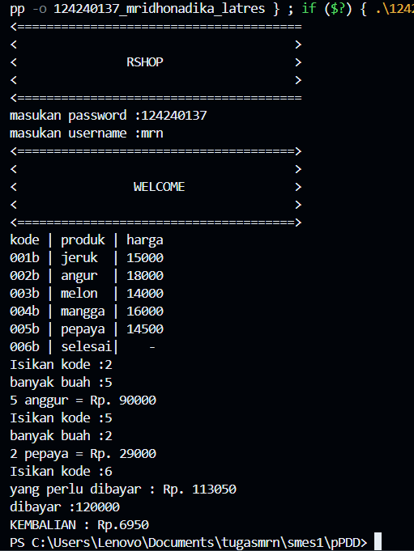

4.4.1 hasil tugas 4